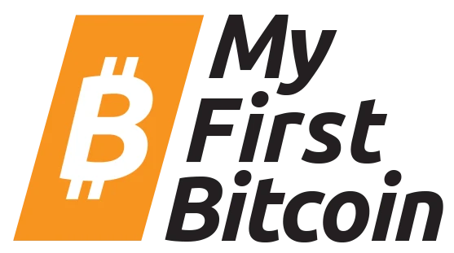

My First Bitcoin

**Activity Training**

# 2024 Edition

Vision

01 Vision

*“A revolutionary leadership must accordingly practise* ***co-intentional*** *education. Teachers and students (leadership and people), co-intent on reality, are both Subjects, not only in the task of unveiling that reality, and thereby coming to know it critically, but in the task of* ***re-creating that knowledge****. As they attain this knowledge of reality through common reflection and action, they discover themselves as its permanent re-creators. In this way, the presence of the oppressed in the struggle for their liberation will be what it should be: not pseudo-participation, but committed involvement”*

**Paulo Freire.**

My First Bitcoin is built around a core concept: that independent, impartial, community-led Bitcoin education will change the world.

This isn’t about Bitcoin, but rather what Bitcoin will teach us: critical thought, personal responsibility and ultimately self-sovereignty. It teaches us to lower our time preference and look further into the future—and that changes everything. When we have control over our lives and future, it encourages us to **build and plan**.

Our highest-level strategy has three prongs:

**First;** create an example in El Salvador that demonstrates and documents Bitcoin education as a tool for empowerment at mass scale**.**

**Second;** create a toolkit to make that example easy to copy by open-sourcing everything & creating easy, international communication channels.

**Third;** create a common banner under which diverse interests can align–we don’t have to agree on other things, but independent, impartial, community-led bitcoin education is something for all to rally behind. A rising tide raises all boats.

Activity One:

Sat Race

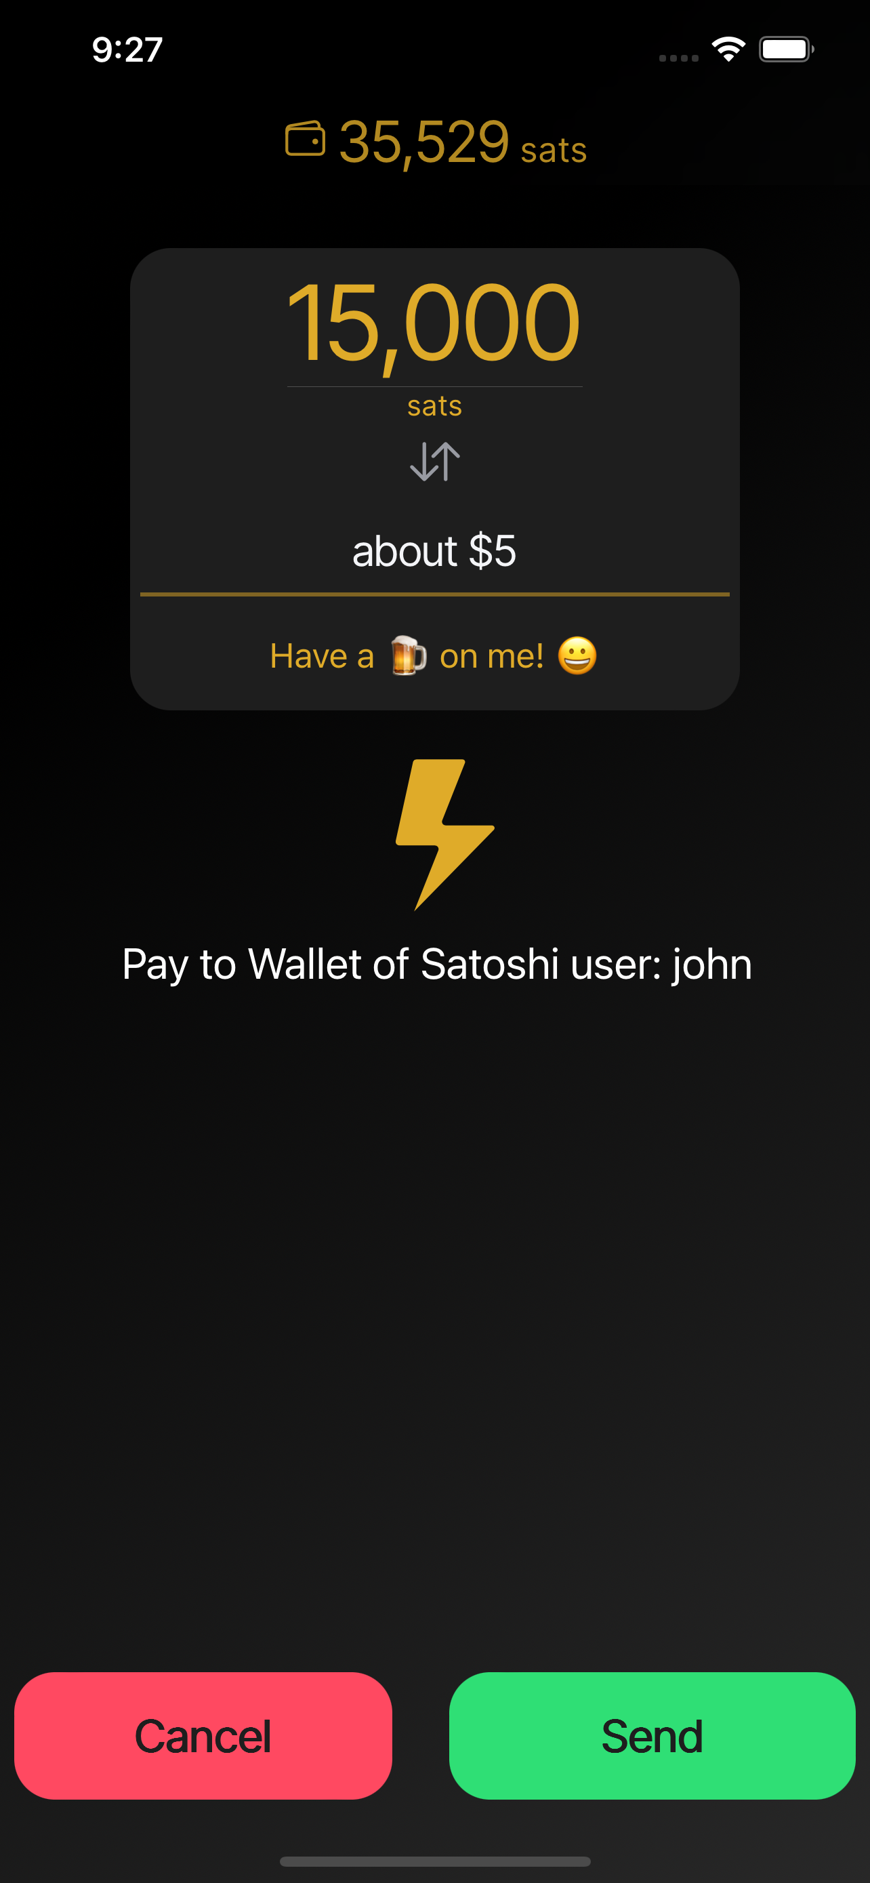

01 Sat Race

1. Arrange students into two equal columns, standing one behind the other.
2. Send the student at the front of the line 10,000 sats.
3. The student should then send the maximum number of sats to the person standing behind them.
4. The group that is able to send the sats to the back of the column, and back to the front, wins a 10,000 sat prize!

The intention of the first activity is to introduce the students to bitcoin by asking them to engage with the lightning network.

Students will need to download a simple lightning wallet, like Wallet of Satoshi.

Difficulty Adjustment:

To finish the race, the final student must generate an invoice for the full amount.

01 Questions for Discussion

Why are you interested to learn about Bitcoin?

What do you know about Bitcoin already?

What is Bitcoin for?

Who should use Bitcoin?

What is different about downloading a lightning wallet compared to opening a bank account?

What are you hoping to learn about Bitcoin during this course?

Can you think of a reason why you would pay someone a very small amount of sats?

Why is Bitcoin important to you?

Activity Two:

What is Money?

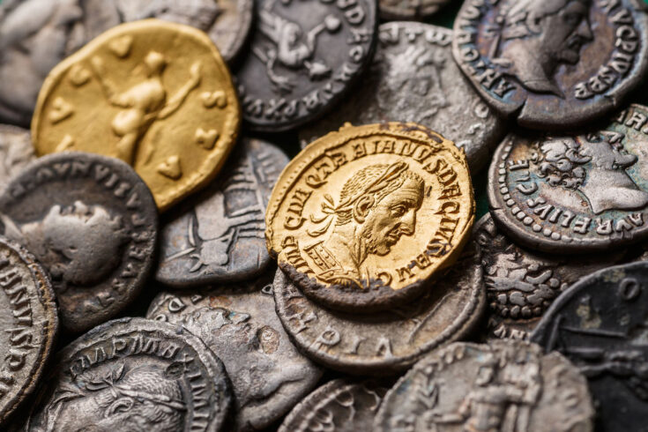

02 What is Money?

1. Have a variety of money available for the students to interact with. This can include fiat paper notes from other countries, precious stones, sea-shells, gold and silver coins.
2. Pass the items around the class.
3. Use the discussion questions to provoke discussion about the qualities of money.
4. Compare the qualities of each money with Bitcoin.

The intention of the activity is to introduce the students to the concept of money. How is money defined and used? What are the characteristics of good money?

Difficulty Adjustment:

Ask the students to rank each money’s characteristics from 1-5 using page 21.

02 Questions for Discussion

When the money has been distributed, ask the students, who would swap their type of money for a chocolate bar? Why? Why not?

Why is gold more valuable than silver?

Why does gold’s chemical composition make it a good money?

Why is it important that a money is scarce?

Why is it important that money is difficult to produce more of?

What do you notice about the paper money?

What are the similarities between the various paper monies that are on display?

Why do you think that the paper money has special signs and images on it?

Which money do you think is the most valuable? Why?

Who decides what people use as money?

What would you do if you could control the supply of new money?

Activity Three:

Time Preference

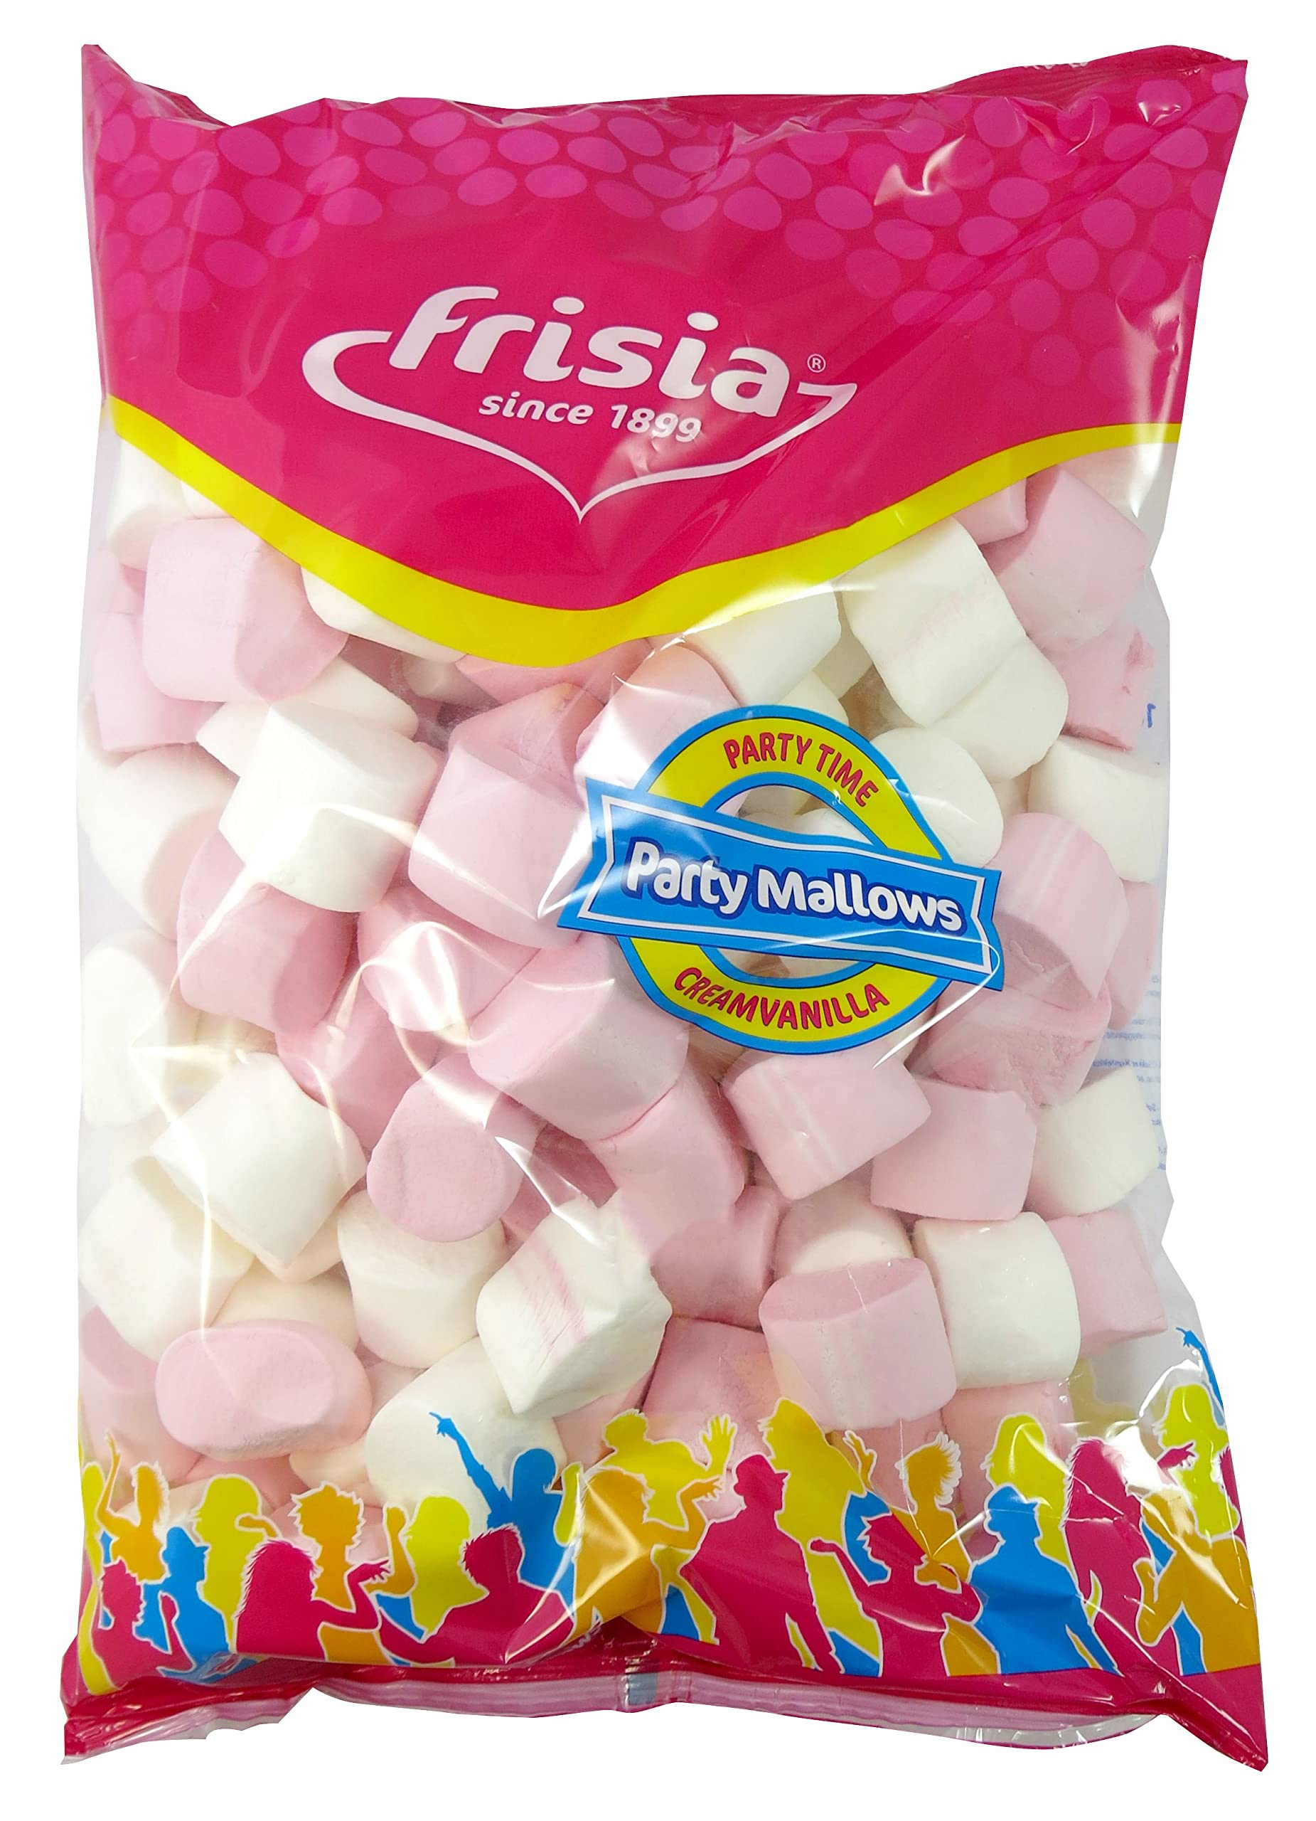

03 Time-Preference Challenge

1. Place one marshmallow on the desk of each student.
2. At the start of the lesson, tell the students that if they can resist eating the marshmallow for the entire lesson, they can have three marshmallows at the end of the lesson.
3. At the end of the lesson, reward the students who practised low time-preference.
4. Discuss time-preference as a class.

The intention of the activity is to introduce the students to the concept of time-preference. This is a concept can be introduced in the first or second meeting and can book-end another activity.

Difficulty Adjustment:

Find out the students’ favourite sweets before the lesson, and buy that!

03 Questions for Discussion

What does low time-preference mean?

What does high time-preference mean?

What factors influenced your decision to take the sweets now or wait until later?

Can you give an example of a high time-preference behaviour?

Can you give an example of a time when your behaviour was low time-preference?

Can you give an example of a time when your behaviour was high time-preference?

What would happen if you behaved in a low time-preference more often?

What would happen to a society is everyone behaved in a high time-preference way?

What would happen to a society if everyone behaved in a low time-preference way?

How might this activity affect your financial decisions in the future?

Why do all humans have a positive time preference? Why is it not zero?

What is ‘opportunity cost’?

Activity Four:

From Barter to Bitcoin

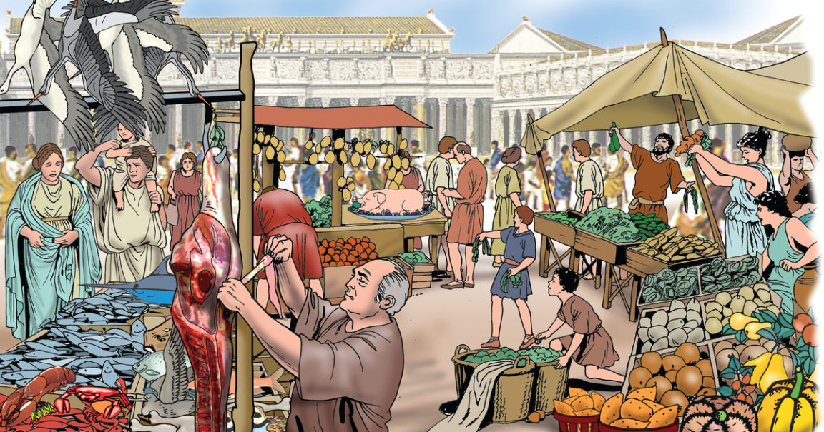

04 Barter Economy

1. Each student gets a card. They must choose 10 items from the board that they either have to sell or want to buy.
2. Students must walk around the class and find someone who wants what they have, and is in possession of something they want.
3. The students are allowed to exchange with as many people as they want.
4. The first activity should continue for around 5 minutes.

The intention of the activity is to introduce the students to the concept of the coincidence of wants.

The teacher will need to print the cards for this activity in advance and set the scene: We are now in ancient Mesopotamia and money doesn’t exist… yet.

Difficulty Adjustment:

A student that is able to complete their ‘wants’ in 3 min gets a small reward.

|  |
| --- |
| Five pigs |
| Four kilos of wheat |
| One dozen eggs |
| A horse |
| A sack of apples |
| A basket of wool |
| A pair of boots |
| A barrel of honey |
| Three chickens |
| A sack of rice |
| A pair of leather gloves |
| A bucket of milk |
| Two liters of olive oil |
| A sack of potatoes |
| An umbrella |
| Two sheep |
| A bag of coffee |
| A sack of oranges |
| A wool blanket |
| A sack of corn |
| A pair of slippers |
| A pack of tomato seeds |
| A basket of strawberries |
| A hat |

| To BUY | To SELL |
| --- | --- |
|  |  |
|  |  |
|  |  |
|  |  |
|  |  |

| To BUY | To SELL |
| --- | --- |
|  |  |
|  |  |
|  |  |
|  |  |
|  |  |

04 Questions for Discussion

How did you feel during the activity?

Why are some students able to trade successfully?

Why are some students unsuccessful?

What are the benefits of barter?

What are the drawbacks of barter?

What would happen if we had to go back to using barter today?

Can you see any items that would not exist if we had to rely on barter?

How would a barter economy affect time preference?

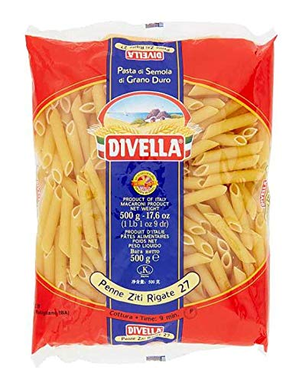

04 Introduction of Money

1. Distribute some dry pasta (or any item you choose) to the class. Introduce the concept of commodity money.
2. The students can now repeat the activity using the pasta as a medium of exchange.
3. Set a timer to see how long it takes for the students to buy and sell the items required.

The intention of the activity is to introduce the students to the concept of how money solves the problem of a coincidence of wants.

The barter activity should be completed first.

Difficulty Adjustment:

Don’t distribute the pasta evenly; some get more than others.

04 Questions for Discussion

Why did the activity take much less time to complete?

How did you feel during the activity compared to the bartering activity?

Why do you think money replaced bartering?

What are the benefits of using a commodity money?

Can you think of any disadvantages of using a commodity money?

What other items could be used as commodity money?

Why is gold a better commodity money than pasta?

Activity Five:

Auction!



05 Auction!

1. The teacher distributes monopoly money to the class, unevenly.
2. The teacher offers a bar of chocolate for auction.
3. The teacher distributes more money to the class, again unevenly.
4. Another auction takes place for a second chocolate bar.
5. For a third time, more money is distributed to the class.
6. A final auction is held for the third chocolate bar.

The intention of the activity is to introduce the students to the concept of inflation of prices as the amount of money in circulation increases. The teacher needs three identical chocolate bars. The monopoly money represents the money supply in an economy.

Difficulty Adjustment:

Only the students with the most money get more money in the third round. Or the teacher’s ‘favourite’ students.

05 Questions for Discussion

Why is the distribution of money at the start of the activity uneven?

How did it feel to have less money given to you?

How did it feel to get extra money given to you?

Why do some people have a better chance of winning the auction?

How did the price of the chocolate bars change?

The chocolate bars are exactly the same, so why did they sell for different prices?

In the third auction, only the students with the most money got more money. What do you think about this?

Why do you think the teacher (or government) might choose who gets to receive the money?

Can you think of any real world examples where this happens?

What problems might be caused in society by a changing supply of money?

**Important:**

The teacher can explain the **Cantillon Effect** during this activity.

Activity Six:

A Fraction in Reserve

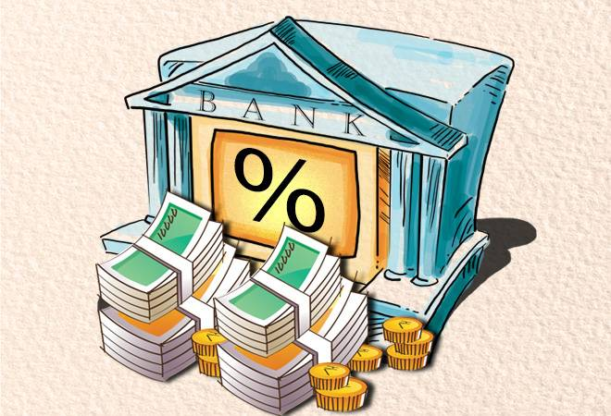

06 A Fraction in Reserve

1. Assign roles to the students.
2. Walk the students through the steps, with each student coming to the front of the class to make their transaction.
3. Keep note of the transactions on the whiteboard as they happen.
4. For each step, ask the students to calculate the 10% reserve that must be kept in the bank at all times.

The intention of the activity is to introduce the students to the concept of fractional reserve banking, and how the money supply can be expanded dramatically by this mechanism. The teacher needs to use a whiteboard. A calculator is useful too!

Difficulty Adjustment:

Ask the students to complete the activity again, but with a different amount at the start and for different reasons.

|  |  |  |  |  |  |  |
| --- | --- | --- | --- | --- | --- | --- |
| **Step** | **Event** | **Reserve Ratio** | **Deposits** | **Loans** | **Reserves** | **Total Deposits** |
| 1 | Depositor A deposits $100,000 in the bank. | 10% | $100,000 | $0 | $10,000 | $100,000 |
| 2 | Debtor C borrows $90,000 from the bank. | 10% |  | $90,000 | $10,000 |  |
| 3 | Property Owner/Depositor D receives a $90,000 check from Debtor C and deposits it in the bank. | 10% | $90,000 |  | $10,000+$9,000= $19,000 | $190,000 |
| 4 | Debtor E borrows $81,000 from the bank. | 10% |  | $81,000 | $19,000 |  |
| 5 | Art Gallery Owner/Depositor F receives the $81,000 from Debtor E's loan and deposits it in the bank. | 10% | $81,000 |  | $10,000+$9000+ $8,100= $27,100 | $271,000 |

Step 0: Assign roles to each volunteer, as follows:

* A = Depositor (Lottery Winner) (light blue)
* B = Bank Cashier (bank)
* C = Debtor #1 (dark blue)
* D = Property Owner/Depositor (red)
* E = Debtor #2 (light Purple)
* F = Art Gallery Owner/ Depositor (green)

Step 1: Depositor A (Lottery Winner) deposits $100,000 in the bank.

* The bank must keep 10% of $100,000 as reserves, which is $10,000.
* The bank can lend out the remaining $90,000.

Step 2: Debtor C borrows the maximum amount of $90,000 from the bank to put a down payment on a house.

* The bank now has $10,000 in reserves and has lent out $90,000 to Debtor C.

Step 3: Debtor C writes a check for $90,000 to Property Owner/Depositor D, who then deposits it in the bank.

* The bank now has $10,000 in reserves and $90,000 additional deposits from Property Owner/Depositor D.

Step 4: The total deposits in the bank at this point are $190,000 ($100,000 from depositor A + $90,000 deposit from Depositor D).

The total reserves should be $19,000, but only $9,000 needs to be added to the existing $10,000 reserve

Step 5: Debtor E borrows the maximum amount of $81,000 from the bank (available from the new $90,000 deposit) to buy a piece of art from Art Gallery Owner/Depositor F.

* The bank now has $19,000 in reserves and has lent out $171,000 ($90,000 to Debtor C + $81,000 to Debtor E).

Step 6: Art Gallery Owner/Depositor F deposits the $81,000 from Debtor E's loan in the bank.

* The bank now has $27,100 in reserves and $271,000 in deposits ($100,000 from Depositor A + $90,000 from Property Owner/Depositor D + $81,000 from Art Gallery Owner/Depositor F).

Step 7: The circulated money continues to end up in other banks, which can then use it to make their own loans and investments. This process continues until the $100,000 initial deposit has created $900,000 in new money through loans and deposits. The total money in circulation is $1,000,000= $100,000 +$900,000. We will see how to calculate this with a simple formula.

06 Questions for Discussion

What are the advantages to the bank by keeping only a fraction of deposits in reserve?

Can you think of any problems that could occur with this type of system?

What would happen if all the depositors asked to withdraw their money at the same time?

What is the keyword / technical term used when this happens?

We used 10% as an example; what do you think the current reserve requirements are for the banks? (<10%)

What is the benefit to the banks to use this system?

Are there any other benefits to using this system?

What are the disadvantages to using this system?

Who benefits the most from using this system?

How does this incentivise students’ career choices?

What influence does this have on society as a whole?

What **opportunity costs** are associated with this phenomenon?

Activity Seven:

The Byzantine General’s Problem

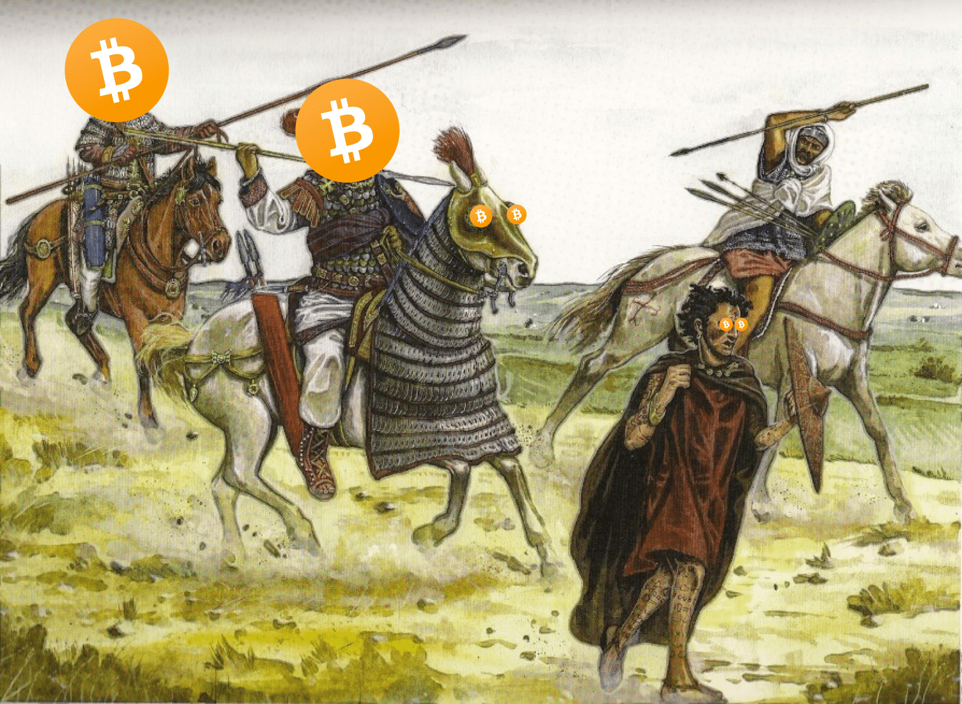

0*7* Byzantine General’s Problem

1. Students are standing in a circle. The teacher explains that he/she is the General, organising an attack and that there are two spies in the group. There is one rule: you can only whisper in the ear of one person at a time.
2. The teacher whispers either ‘attack’ or ‘retreat’ into the ear of two students. The students then whisper the instructions to the person next to them.
3. Once everyone has received some instruction. They can check with the person opposite them.
4. Still standing in a circle the group are told that they must either charge to the front of the room or retreat to the back of the room. Only if they move together will they be successful.

The intention of the activity is to introduce the students to the concept of the Byzantine General’s Problem. The students do not need to know the solution… yet. At the start of the lesson the teacher needs to secretly tell two students that they are spies.

Difficulty Adjustment:

Ask the students to consider how this applies to central banking and money.

07 Questions for Discussion

What did you find challenging about this activity?

What does the activity show you?

Why is it difficult to reach consensus / agreement during a conflict?

How would you adapt the rules of the game so that you can win? Option to play the game with new rules.

Who is in conflict in the context of the monetary system?

Would it help if the generals were able to use a radio or phone to communicate?

Is money a form of communication?

What happens to communication if the method of communication is unclear or distorted?

Could it be argued that printing money is a distortion of money’s signal?

Why does the Byzantine General’s Problem apply to Bitcoin?

In bitcoin, who is the general?

Can the Byzantine Generals’ Problem be solved twice?

Activity Eight: Generating and securing a Public/Private key.

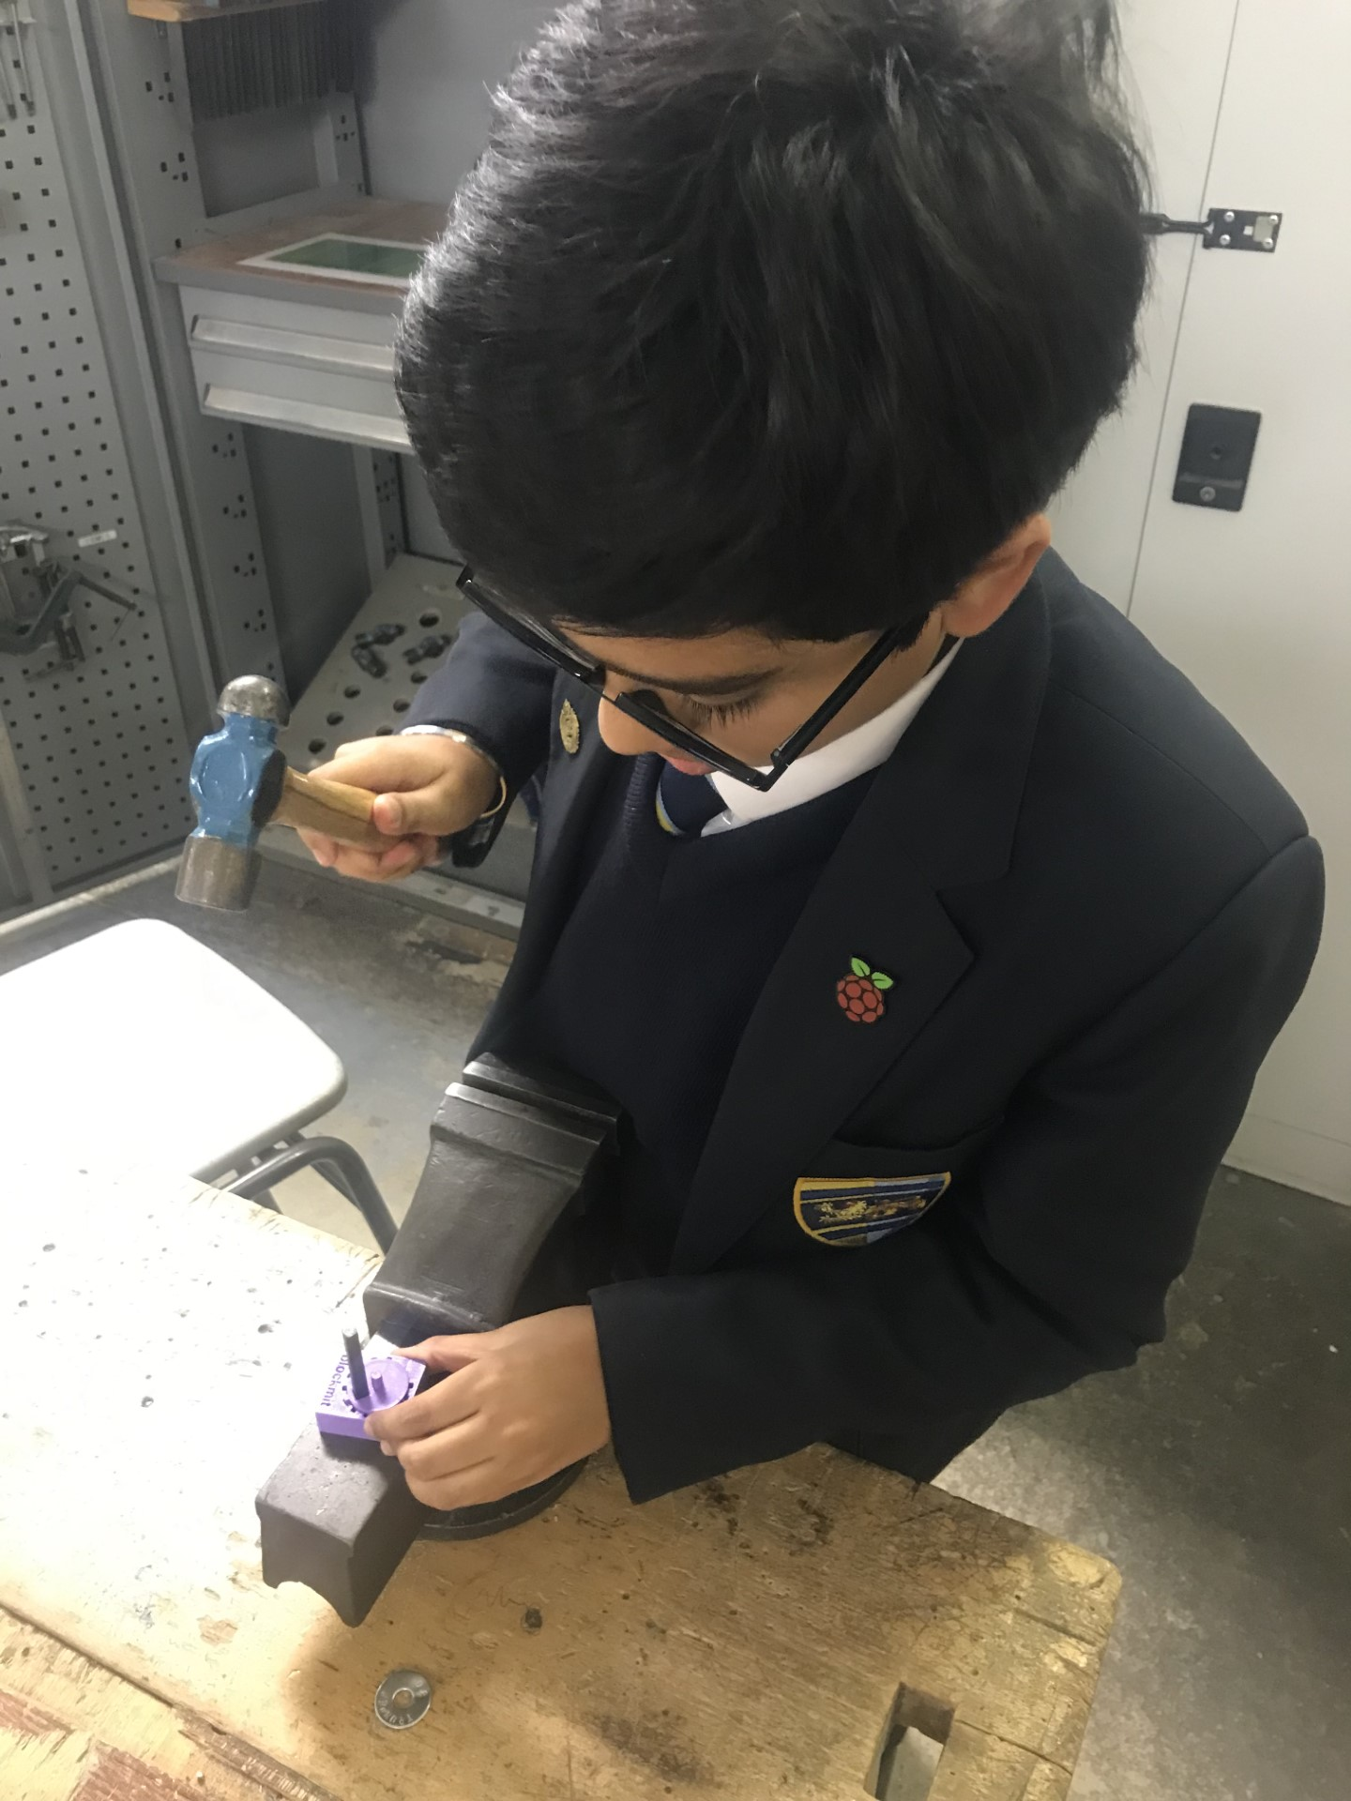

08 Generating and Securing a Public / Private Key Pair

1. Following Wicked’s excellent instructions, students use 256 pennies to generate one set of private keys in binary.
2. Students then use the BIP39 word list to generate their 12 word seed phrase.
3. Students can use Blue Wallet to generate a public key from this.
4. Ask students to generate a new wallet using Blue Wallet.
5. Using a hammer and stamping kit, students stamp their private keys into metal washers.

The intention of the activity is to illustrate how Bitcoin keys are generated through very large and random numbers. Also, the importance of securing private keys in metal and the responsibility of each individual for taking self-custody and securing their private keys.

Difficulty Adjustment:

What is the difference between a custodial and non-custodial wallet? What is the purpose of a 25th word?

08

Questions for Discussion

How easy would it be for a computer to guess your private keys?

How long do you think it would take for a computer to guess your private keys?

Why is it important that it is possible to generate your private keys using coins and a piece of paper?

Why is metal a better store for your private keys than paper?

What are the problems with storing your seed phrase on metal like this?

What could you do to reduce the chance of someone discovering your seed phrase?

What would happen if you lost access to your seed phrase?

What would happen if someone found your seed phrase?

What are some good locations to store your seed phrase?

Is it a good idea to split your seed phrase in two?

Who is responsible for your seed phrase?

Who is responsible for you? **Extra activities: phishing sweep the wallets from the seed phrase into your own wallet**

Activity Nine:

Phishing Scam

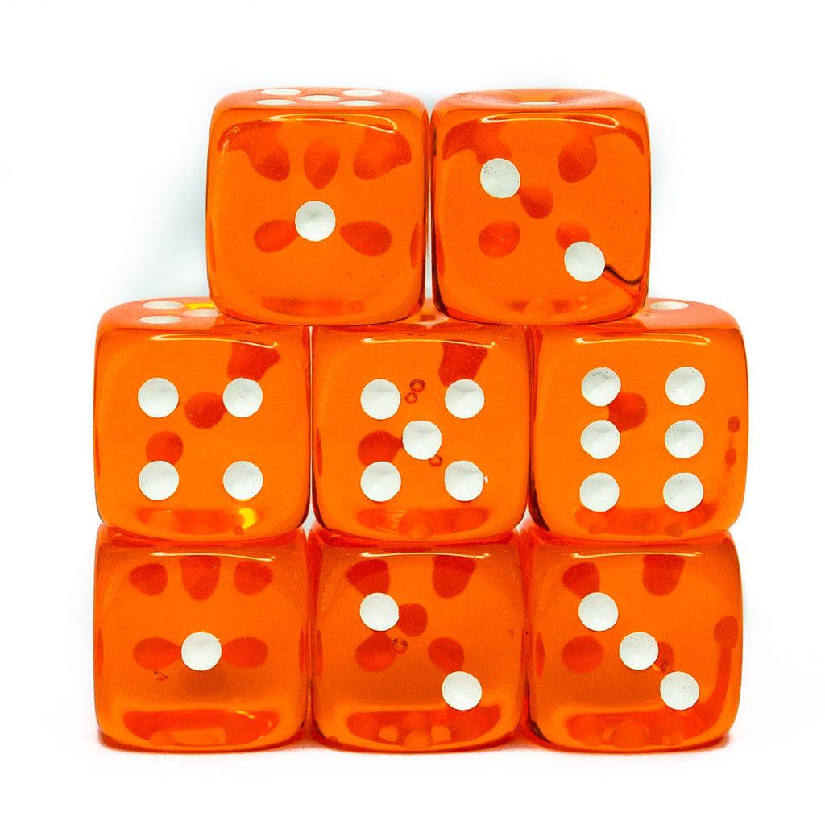

09 Phishing Scam

1. The teacher tells the students that there has been a problem with their hardware wallets and the class activity is to fix it.
2. Tell the class must write their seed phrase in capital letters and give it to their teacher.
3. Folded seed-phrases placed in a hat, teacher takes their pick.
4. The teacher should then project themselves in the act of stealing one students’ bitcoin.

The intention of the activity is to warn the students about the most common attack to steal their bitcoin.

Difficulty Adjustment:

Students to come up with their own phishing scam. What is their approach? Email, phone or in person?

09

Questions for Discussion

How easy would it be for a computer to guess your private keys?

How long do you think it would take for a computer to guess your private keys?

Why is it important that it is possible to generate your private keys using coins and a piece of paper?

Why is metal a better store for your private keys than paper?

What are the problems with storing your seed phrase on metal like this?

What could you do to reduce the chance of someone discovering your seed phrase?

What would happen if you lost access to your seed phrase?

What would happen if someone found your seed phrase?

What are some good locations to store your seed phrase?

Is it a good idea to split your seed phrase in two?

Who is responsible for your seed phrase?

Who is responsible for you? **Extra activities: phishing sweep the wallets from the seed phrase into your own wallet**

Activity Ten:

Sending Bitcoin On-Chain



10 Interactive Mining Exercise

1. The teacher divides the class into miners, nodes and wallets.
2. The wallets must complete the transaction slips and pass them to one node.
3. As the node holds the transaction, the miners roll their dice in search for a ‘1’.
4. When a miner finds a ‘1’, she can write the transaction on her slip and award herself a reward.
5. The nodes must all check that the transaction is valid before adding to the ledger.
6. Keep a ledger on the whiteboard.

The intention of the activity is to introduce the students to the concept of mining as a decentralised game of probability with an energy cost. The teacher needs a supply of dice to complete the activity.

Difficulty Adjustment:

The difficulty should be adjusted by requiring two, then three, then four ‘1’s. The teacher can add and remove miners.

The target number can also be the sum of the dice value

10 Questions for Discussion

What could we do to decrease the time required to find the target number?

What could we do to increase the time required to find the target number?

How does adding more miners change the time required?

How does removing miners change the time required?

How is energy involved in finding the target number?

Is there any way to cheat at this game? How do you think Bitcoin stops this?

What are the nodes doing?

What is required for a transaction to be sent from one wallet to another wallet?

What do the miners do? How long does it take to find a target number in Bitcoin?

Where is the proof-of-work?

Why did Satoshi include a Difficulty Adjustment?

What happens when the final coins are mined?

| A bitcoin transaction | |
| --- | --- |
| Address of sender |  |
| Address of receiver |  |
| Amount of bitcoin held in wallet |  |
| Amount of bitcoin to send |  |
| Transaction Fee |  |
| Signature of sender |  |
| Held in node mempool |  |
| Added to block by miner |  |
| Confirmed by node |  |

| A bitcoin transaction | |
| --- | --- |
| Address of sender |  |
| Address of receiver |  |
| Amount of bitcoin held in wallet |  |
| Amount of bitcoin to send |  |
| Transaction Fee |  |
| Signature of sender |  |
| Held in node mempool |  |
| Added to block by miner |  |
| Confirmed by node |  |

Activity Eleven:

Running Bitcoin

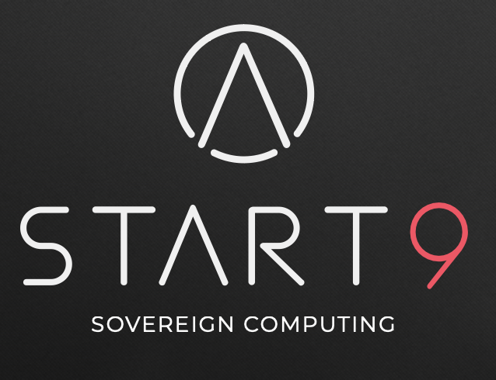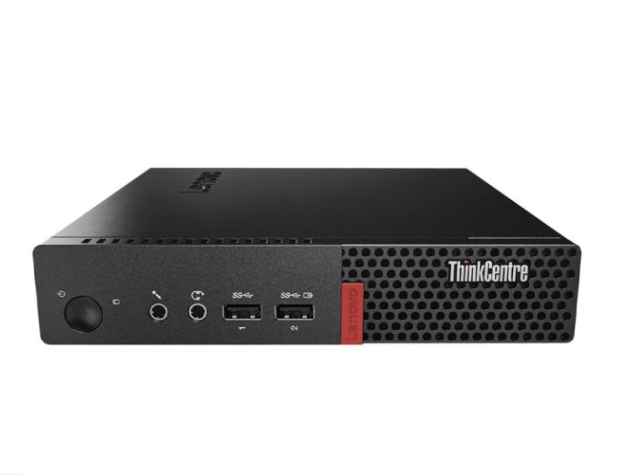

11 Building a Node

1. Introduce the students to the hardware components of the node. Pass it around so that all the students can see.
2. Classroom discussion about the RAM and the SSD.
3. Discuss the requirements and options for a node.
4. Begin installation of Start 9 OS.
5. Install Bitcoin Core and mempool.space for next lesson.

The intention of the activity is to introduce the students to how easy and inexpensive it is for non-technical people to build and operate a node, by upgrading hardware and using free software. Some collaboration with the IT department is required in advance.

Difficulty Adjustment:

Connect a wallet to the node and verify your own transactions.

11 Questions for Discussion

What does a node do? Why are nodes different to miners? Do nodes use POW?

What is RAM? What is SSD?

What is the current size of the Bitcoin Timechain?

What is Moore’s Law?

What is the maximum amount of data that can be included in one block?

Why did Satoshi keep the amount of data in a block limited to 1MB?

What data is kept in the RAM?

What data is kept in the SSD? Why does it take so long to install Bitcoin Core?

Who should run a node?

Why should you run your own node?

Where should you keep your node?

What else can you do with a node?

Activity Twelve: Exploring the Mempool

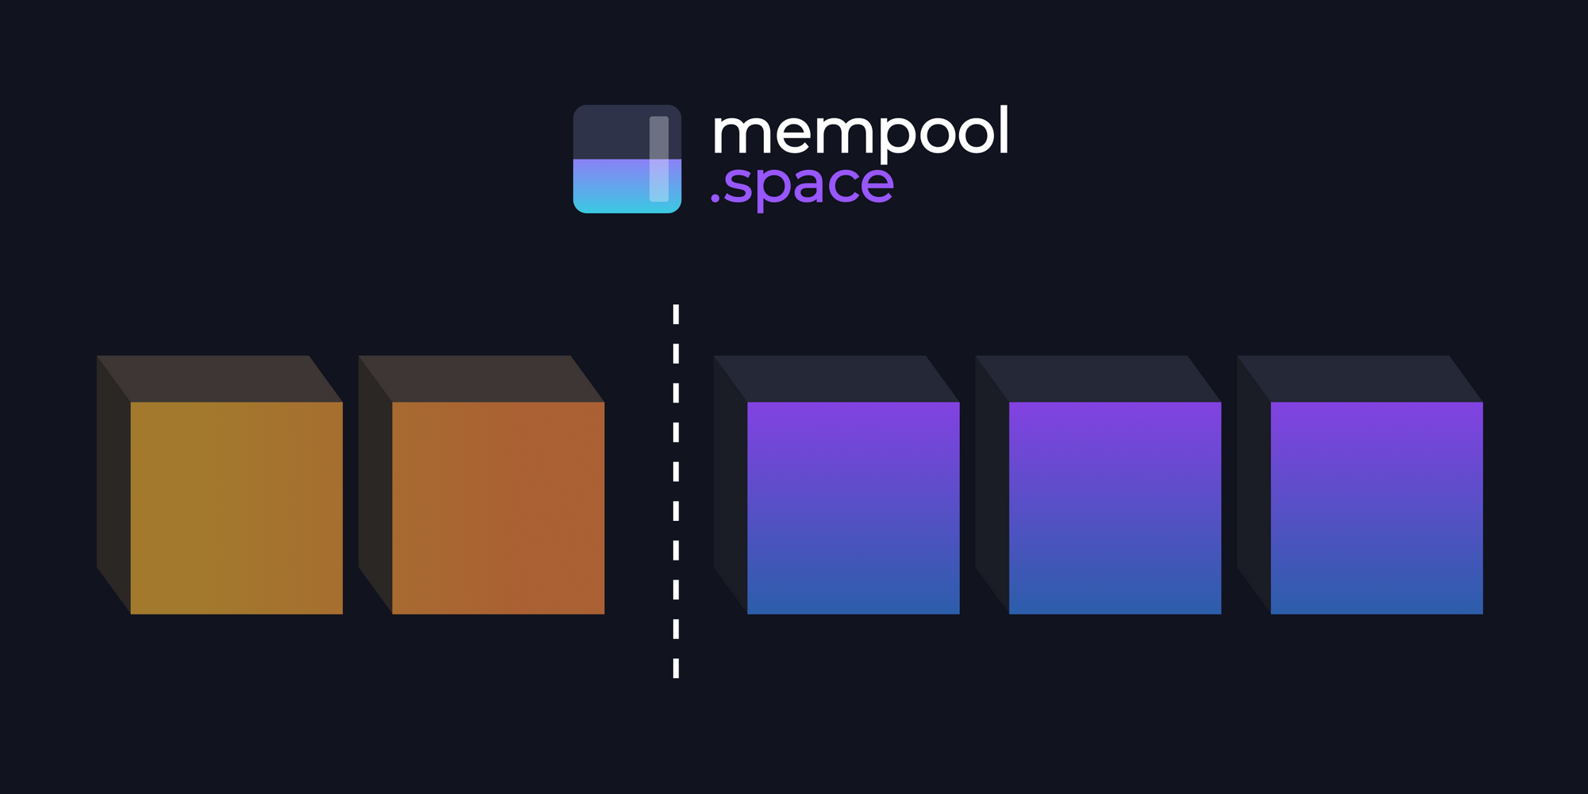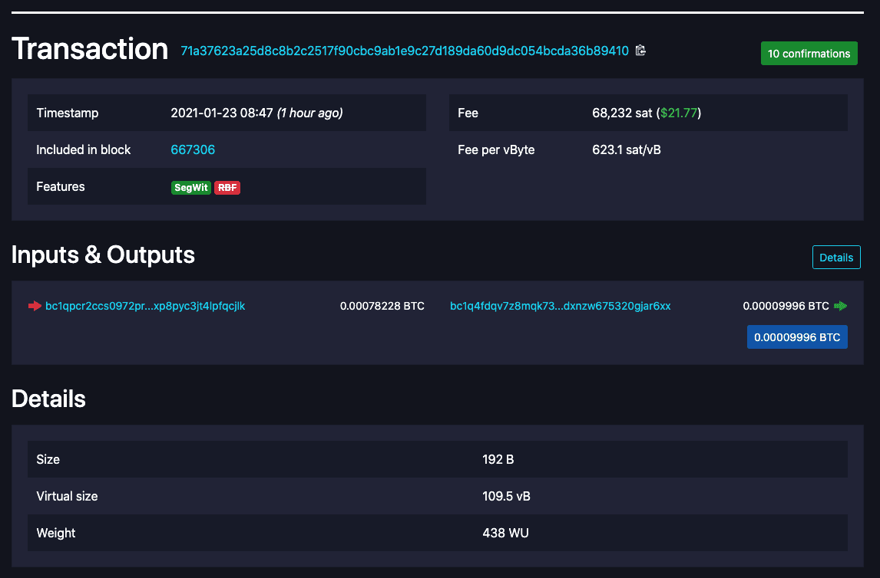

11 Exploring the Mempool

1. Teacher shows students how to navigate mempool.space and shows how to explore the UI.
2. Students are invited to visit the website on their own devices (ideally a laptop or in the school computer room) and to examine various transactions as they please.
3. Class discussion and questions.

The intention of the activity is to introduce the students to the mempool.space visualiser and block explorer so that they can see transactions being confirmed in real time. This is a good starter activity and can lead to excellent classroom discussion.

Difficulty Adjustment:

Send a transaction and find it using the explorer.

11 Questions for Discussion

Why can we see the entire history of transactions?

Why could it be a problem if someone can match your identity to your transactions?

Why does the time between blocks vary?

What does the size of the coloured blocks in each block represent?

What is the difficulty adjustment? Why is the difficulty adjustment necessary?

Why do the fees go up and down?

What is the Mempool?

Why is the Mempool different on every node?

What happens if you use someone else’s node?

Is it urgent to run a node?

What other advantages do you get from running a node or sovereign server?